**Group:** (2009020, 2009024, 2009028, 2009032).

**Course No.**: **ECE 2200**

**Project:** **Construction of power bank**

**Introduction:**

In today's tech-driven world, our reliance on gadgets such as smartphones, iPods, and smartwatches has become indispensable. However, a common challenge we face with these devices is the need for regular recharging, which can be particularly problematic in areas without access to electricity. One innovative solution to address this issue is using a power bank. This power bank can be used for charging smartphones. This power bank circuit uses two integrated modules and a lithium-ion battery. The first module is a lithium-ion battery charger and the second is a DC-DC boost converter module.. In this project, we design a power bank. This circuit not only allows us to charge our mobile phones but also includes safeguards to prevent overcharging and protect the battery.

**Proposed Features:**

* Multiple charging option
* Over charge protection
* Stored energy
* Battery voltage integrator

**Apparatus Required:**

Table no 1.1: Required apparatus to design a DC power supply

|  |  |  |  |  |
| --- | --- | --- | --- | --- |
| SL  No. | Name of the Apparatus | Rating | Quantity | Price per piece(Taka) |
| 01 | Op amp  LM741 | 1.7-2.8mA | 01 | 20 |
| 02 | Resistor | 100 ohms, 150 ohms,10k ohms | 3 | 1 |
| 03 | Capacitor | 10µF | 1 | 7 |
| 04 | Micro USB cable | --------- | 1 | 200 |
| 05 | Transistor  BC547 NPN | 60V  15A | 1 | 2 |
| 06 | Regulator  LM317 | 1.5A | 1 | 20 |
| 07 | Switch | 0.01 **Ω** | 2 | 12 |
| 08 | LED (Red, Green and Blue) | 5V | 1 | 1 |
| 09 | Zener Diode 1N4735A | 5.6V, 20mA | 1 | 2 |
| 10 | Diode 1N4001 | 40V, 1A | 2 | 40 |
| 11 | Potentiometer | 0-10 k **Ω** | 1 | 15 |
| Total Estimated Budget = 320/- | | | | |

**Circuit Diagram:**

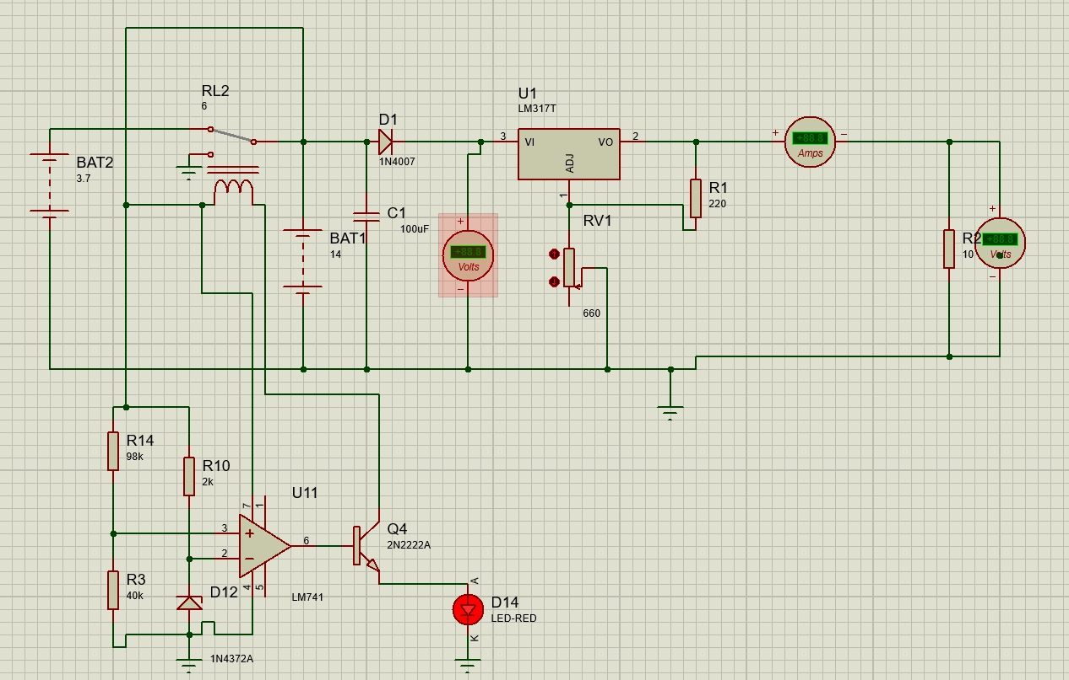

**Discussion:**

In this project, we have designed a power bank circuit with over voltage protection.  In over voltage, Op-Amp is used as comparator and if DC supply exceeds 11.4V then over voltage unit isolates the circuit after rectified output.